39.36: a) 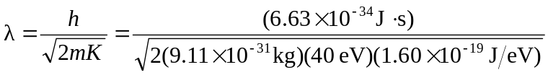
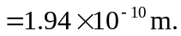
b) 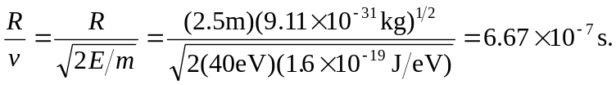
c) The width 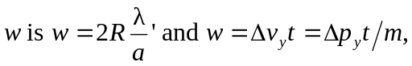 where t is the time found in part (b) and a is the slit width. Combining the expression for 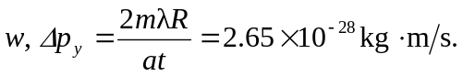
d) 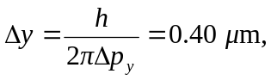 which is the same order of magnitude.

